**PIZZA SALES SQL QUERIES**

**KPI’s:**

1. **Total Revenue**

SELECT SUM(total_price) AS total_revenue FROM pizza_sales;

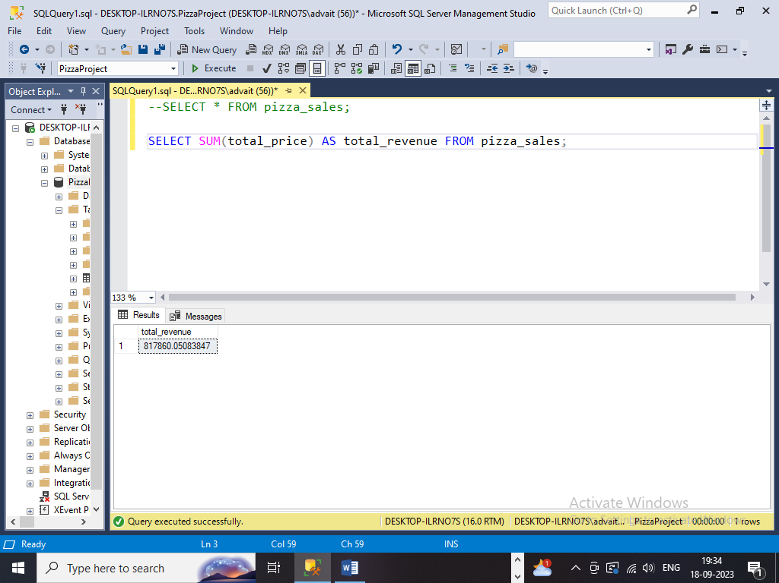

1. **Average Order Value**

SELECT SUM(total_price) / COUNT(DISTINCT order_id) as avg_rev FROM pizza_sales;

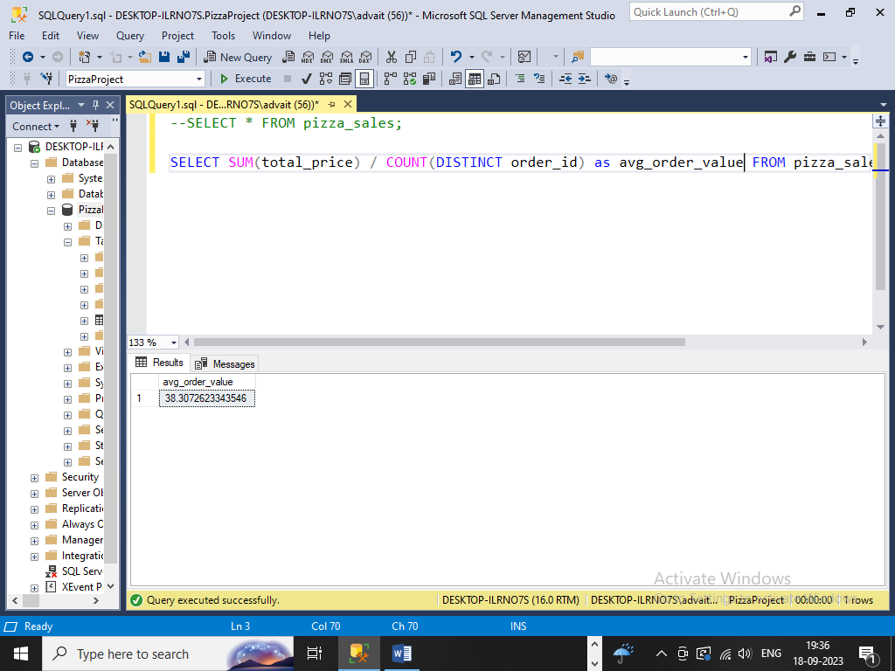

1. **Total Pizza’s Sold**

SELECT SUM(quantity) as total_pizza_sold FROM pizza_sales;

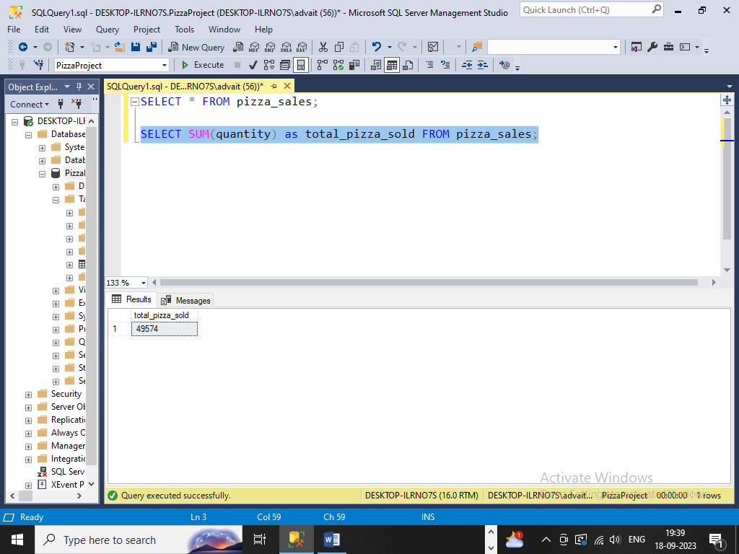

1. **Total Orders**

SELECT COUNT(DISTINCT order_id) as total_orders from pizza_sales;

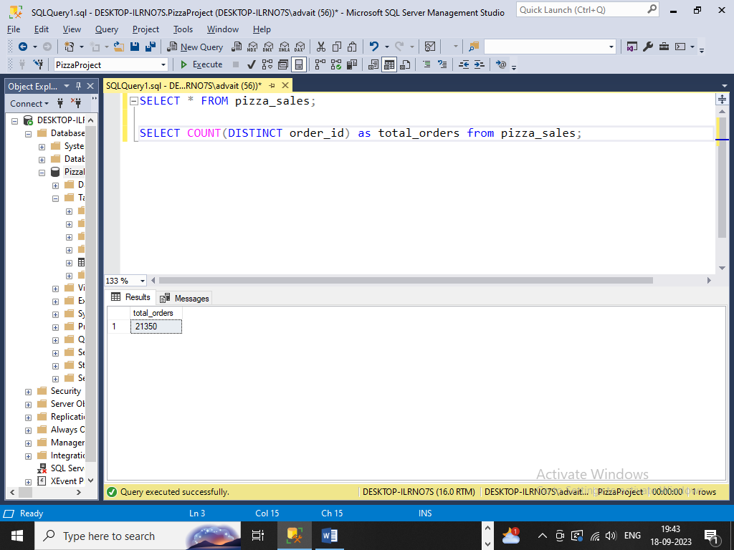

1. **Average Pizza Per Order**

SELECT CAST(CAST(SUM(quantity) AS DECIMAL(10,2)) / CAST(COUNT(DISTINCT order_id) AS DECIMAL(10,2)) AS DECIMAL(10,2)) AS avg_pizza_per_order from pizza_sales;

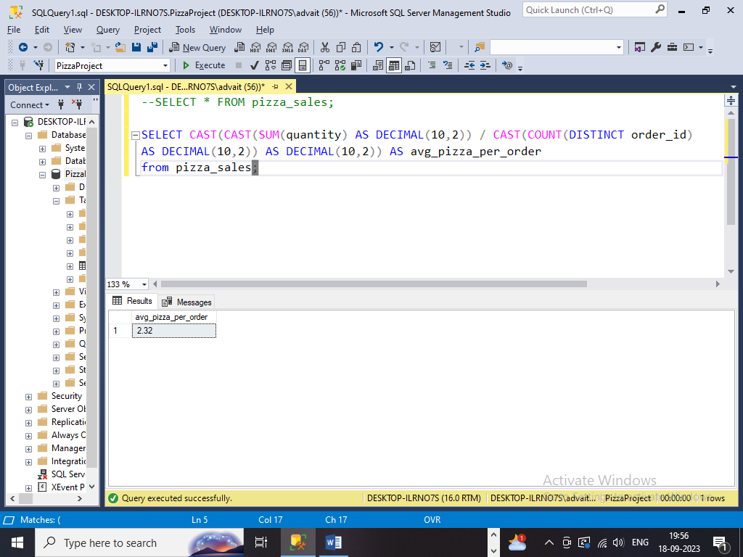

**CHART REQUIREMENT:**

1. **Daily trend for total orders**

SELECT DATENAME(DW, order_date) AS order_day, COUNT(DISTINCT order_id) AS total_orders FROM pizza_sales

GROUP BY DATENAME(DW, order_date);

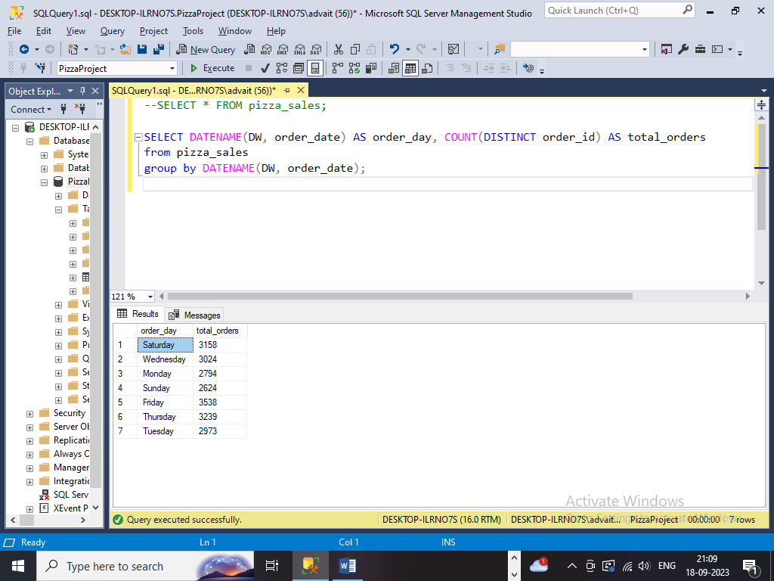

1. **Monthly trend for total orders**

SELECT DATENAME(MONTH, order_date) AS order_month, COUNT(DISTINCT order_id) AS total_orders FROM pizza_sales

GROUP BY DATENAME(MONTH, order_date)

ORDER BY total_orders DESC;

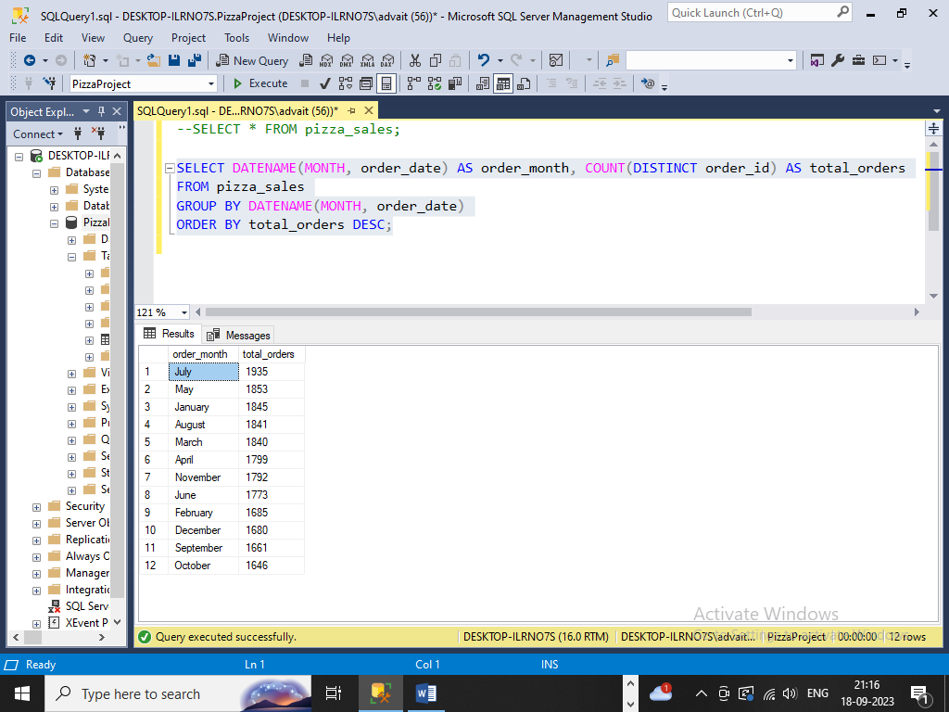

1. **Hourly trend for total orders**

SELECT DATEPART(HOUR, order_time) AS order_hours,

COUNT(DISTINCT order_id) AS total_orders

FROM pizza_sales

GROUP BY DATEPART(HOUR, order_time)

ORDER BY DATEPART(HOUR, order_time);

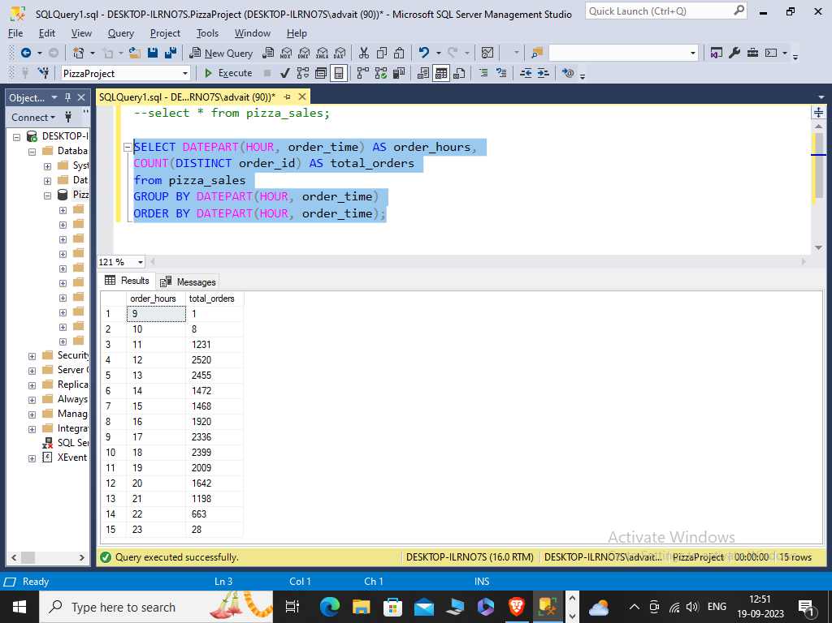

1. **Percentage of sales by pizza category**

SELECT pizza_category,

CAST(SUM(total_price) AS DECIMAL(10,2)) AS total_sales,

CAST((SUM(total_price) * 100 /

(SELECT SUM(total_price) FROM pizza_sales)) AS DECIMAL(10,2)) AS sales_percentage FROM pizza_sales

GROUP BY pizza_category;

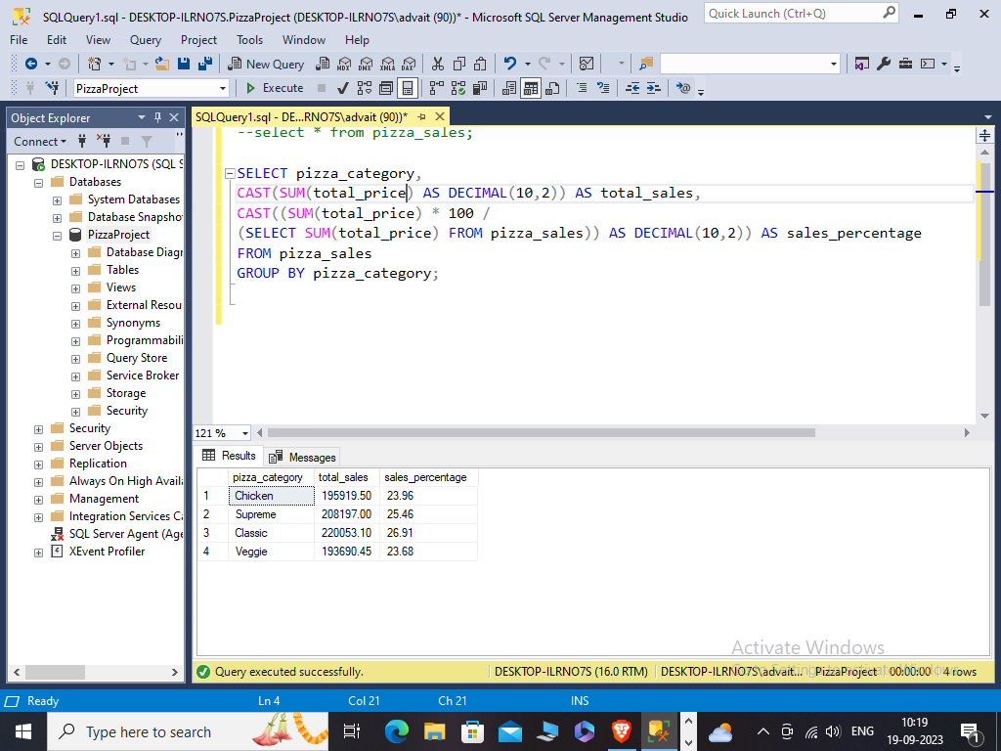

**For month wise:**

SELECT pizza_category,

CAST(SUM(total_price) AS DECIMAL(10,2)) AS total_sales,

CAST((SUM(total_price) * 100 /

(SELECT SUM(total_price) FROM pizza_sales WHERE MONTH(order_date) = 1)) AS DECIMAL(10,2)) AS sales_percentage FROM pizza_sales

WHERE MONTH(order_date) = 1

GROUP BY pizza_category;

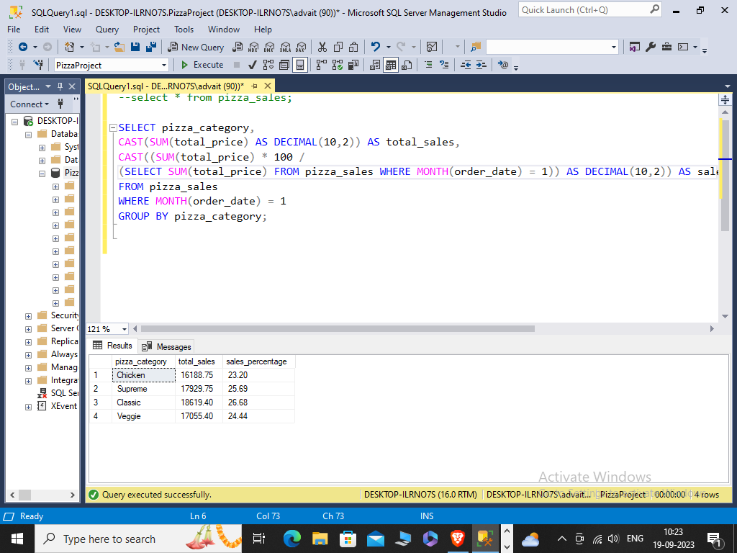

1. **Percentage of sales by pizza size**

SELECT pizza_size,

CAST(SUM(total_price) AS DECIMAL(10,2)) AS total_sales,

CAST((SUM(total_price) * 100 /

(SELECT SUM(total_price) FROM pizza_sales)) AS DECIMAL(10,2)) AS sales_percentage FROM pizza_sales GROUP BY pizza_size

ORDER BY sales_percentage DESC;

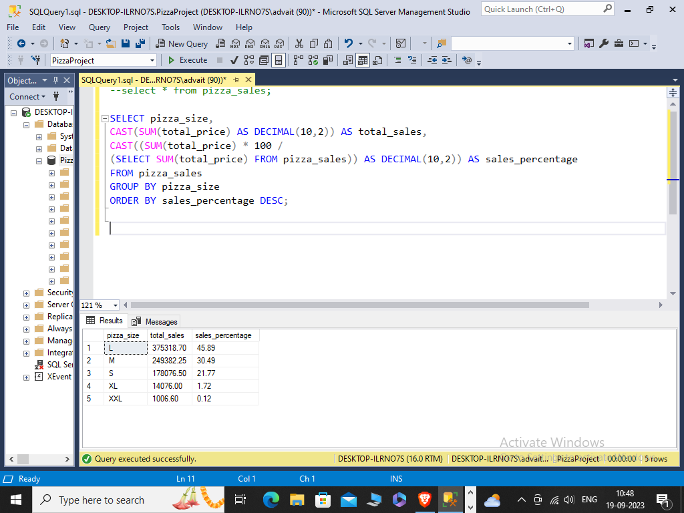

**For quarter wise:**

SELECT pizza_size,

CAST(SUM(total_price) AS DECIMAL(10,2)) AS total_sales,

CAST((SUM(total_price) * 100 /

(SELECT SUM(total_price) FROM pizza_sales WHERE DATEPART(quarter, order_date)=1)) AS DECIMAL(10,2)) AS sales_percentage

FROM pizza_sales

WHERE DATEPART(quarter, order_date) = 1

GROUP BY pizza_size

ORDER BY sales_percentage DESC;

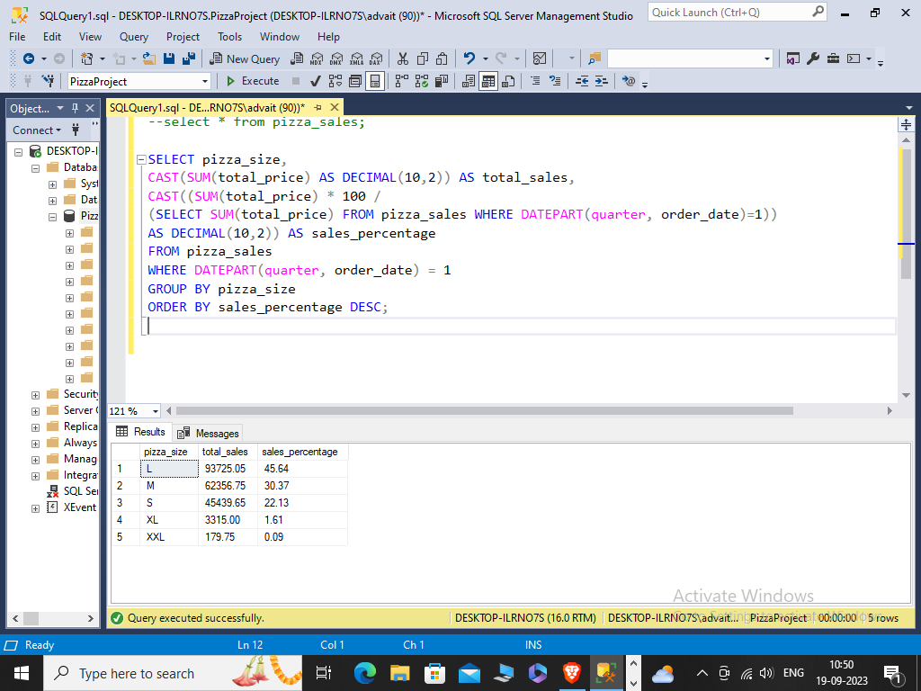

1. **Total pizzas sold by pizza category**

SELECT SUM(quantity) AS quant_category , pizza_category from pizza_sales

GROUP BY pizza_category;

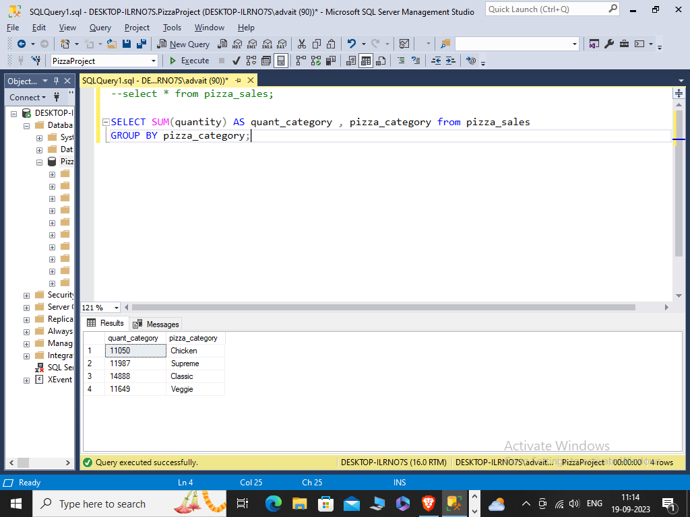

1. **Top 5 pizza by revenue**

SELECT TOP 5 pizza_name, SUM(total_price) AS total_revenue from pizza_sales

GROUP BY pizza_name

ORDER BY total_revenue DESC;

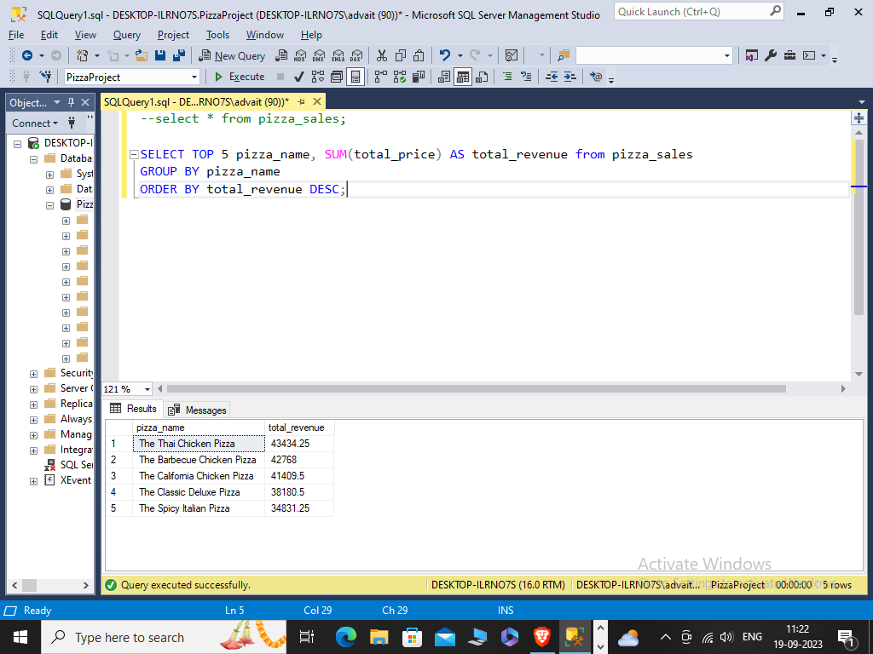

1. **Bottom 5 pizza by revenue**

SELECT TOP 5 pizza_name, CAST(SUM(total_price) AS DECIMAL(10,2)) AS total_revenue from pizza_sales

GROUP BY pizza_name

ORDER BY total_revenue ASC;

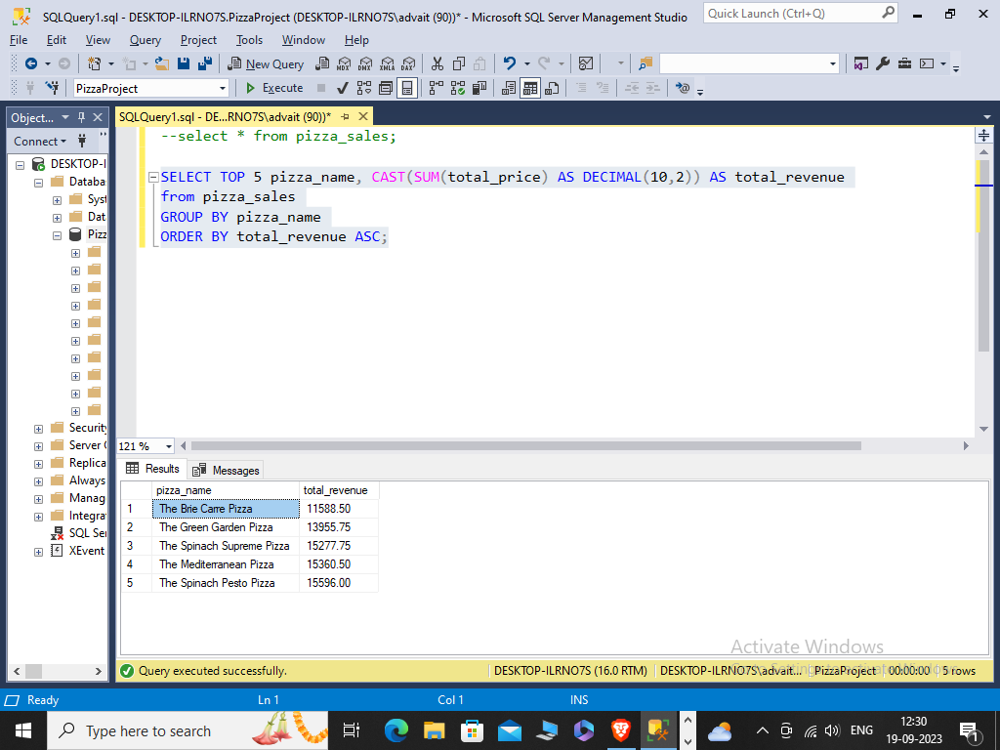

1. **Top 5 pizza by Quantity**

SELECT TOP 5 pizza_name, SUM(quantity) AS total_quantity

from pizza_sales

GROUP BY pizza_name

ORDER BY total_quantity DESC;

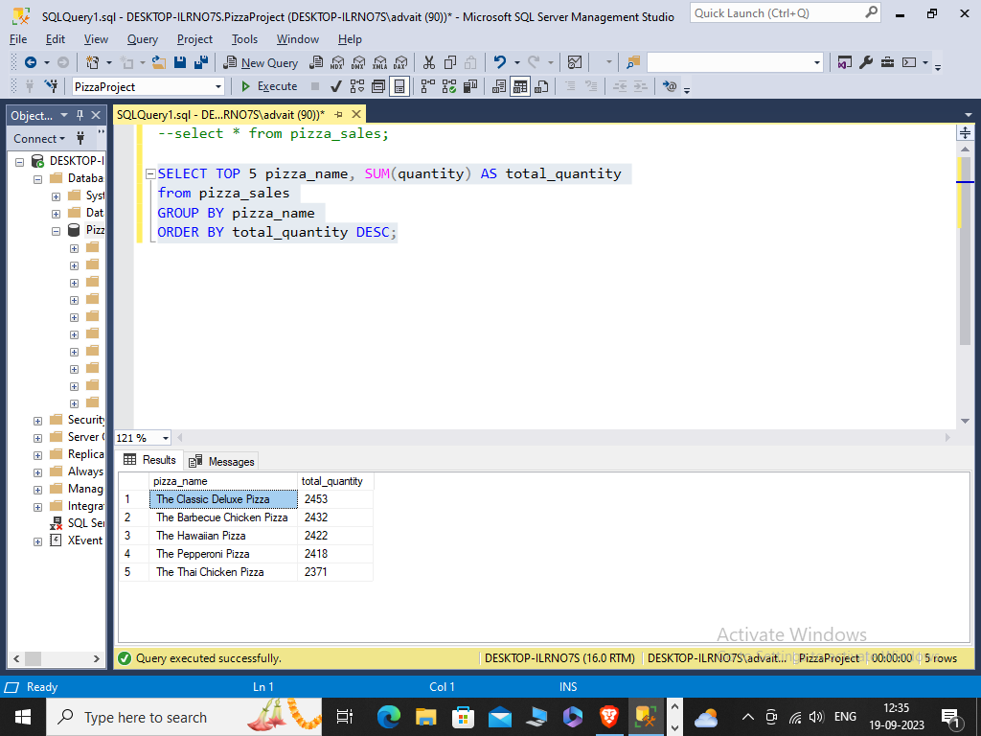

1. **Top 5 pizza by Quantity**

SELECT TOP 5 pizza_name, SUM(quantity) AS total_quantity

from pizza_sales

GROUP BY pizza_name

ORDER BY total_quantity ASC;

